W04 Assignment: YouTube Video Program
- For this assignment, we will write a program that demonstrates your knowledge of abstraction.
Scenario:
- You a hired by a company that monitors product awareness by tracking the placement of their products in YouTube videos.
- The YouTube example is just to give you a context for creating classes to store information. You will not actually be connecting to YouTube or downloading content in any way
Program Specification:
- Write a program to keep track of YouTube videos and comments left on them
- Your program should have a class for a Video that has the responsibility to track the title, author, and length (in seconds) of the video. Each video also has responsibility to store a list of comments and should have a method to return the number of comments.
- A comment should be defined by the Comment class which has the responsibility for tracking both the name of the person who made the comment and the text of the comment.
- Once you have the classes in place, write a program that creates 3-4 videos, sets the appropriate values, and for each one add a list of 3-4 comments (with the commenter’s name and text)’ Put each of these videos in a list.
- Have your program iterate through the list of videos and for each one, display the title, author, length, number of comments (from the method) and then list out all the comments for that video. Repeat this display for each video on the list.
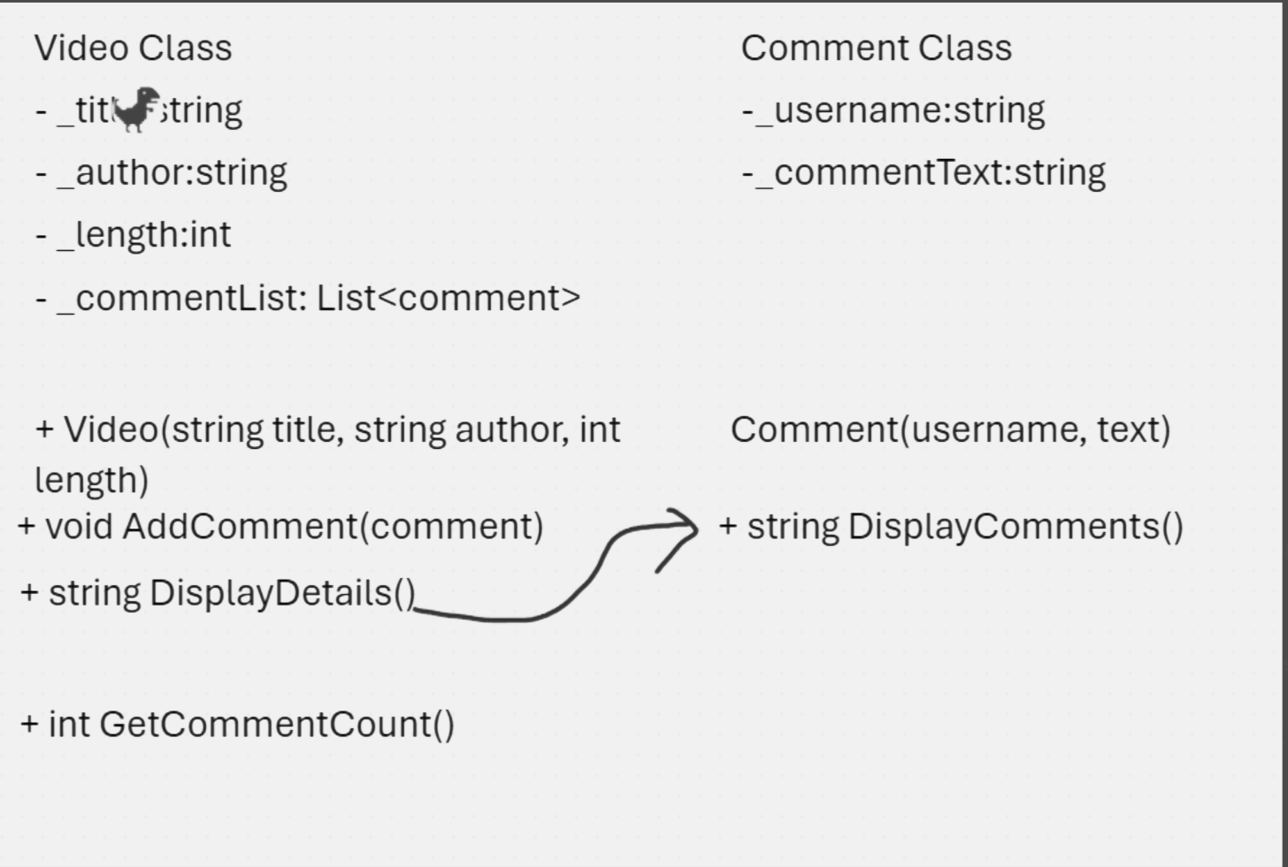
W04 Assignment: Online Ordering Program
Overview:
- Programming with Classes in Encapsulation. For this assignment, we will write a program that demonstrates your knowledge of encapsulation. (Using private variables wherever possible.)
Scenario:
- Assume you have been hired to help a company with their product ordering system. They sell many products online to a variety of customers and need to produce packing labels, shipping labels, and compute final prices for billing.
Program Specification
- Write a program that has classes for Product, Customer, Address, and Order. The responsibilities of these classes are as follows:
- Order
  - Contains a list of products and a customer. Can calculate the total cost of the order. Can return a string for the packing label. Can return a string for the shipping label.
  - The total price is calculated as the sum of the total cost of each product plus a one-time shipping cost.
  - This company is based in the USA. If the customer lives in the USA, then the shipping cost is $5 or if the order is over a certain amount, say $100, the shipping is free. If the customer does not live in the USA, then the shipping cost is $35.
  - A packing label should list the name and product id of each product in order.
  - A shipping label should list the name and address of the customer
- Product
  - Contains the name, product id, price, and quantity of each product.
  - The total cost of this product is computed by multiplying the price per unit and the quantity. (If the price per unit was $3 and they bought 5 of them, the product total cost would be $15.)
- Customer
  - The customer contains a name and an address.
  - The name is a string, but the Address is a class.
  - The customer should have a method that can return whether they live in the USA or not. (Hint this should call a method on the address to find this.)
- Address
  - The address contains a string for the street address, the city, state/province, and country.
  - The address should have a method that can return whether it is in the USA or not.
  - The address should have a method to return a string all of its fields together in one string (with newline characters where appropriate)
